# Weekly Report – 19.11.2018

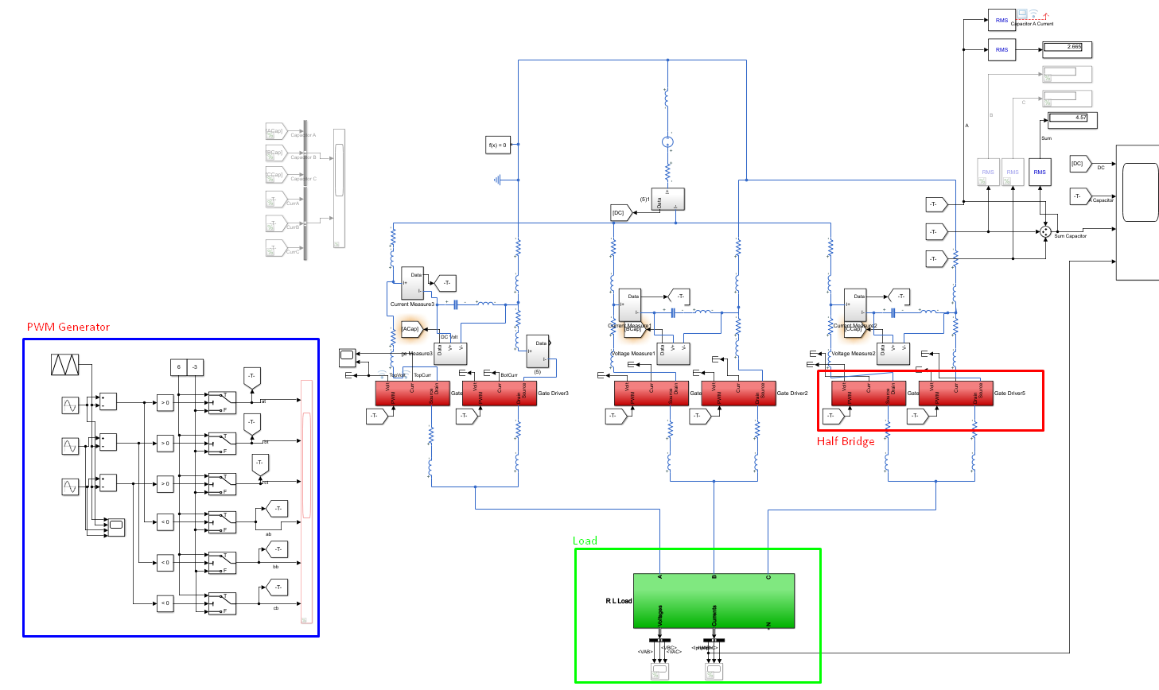

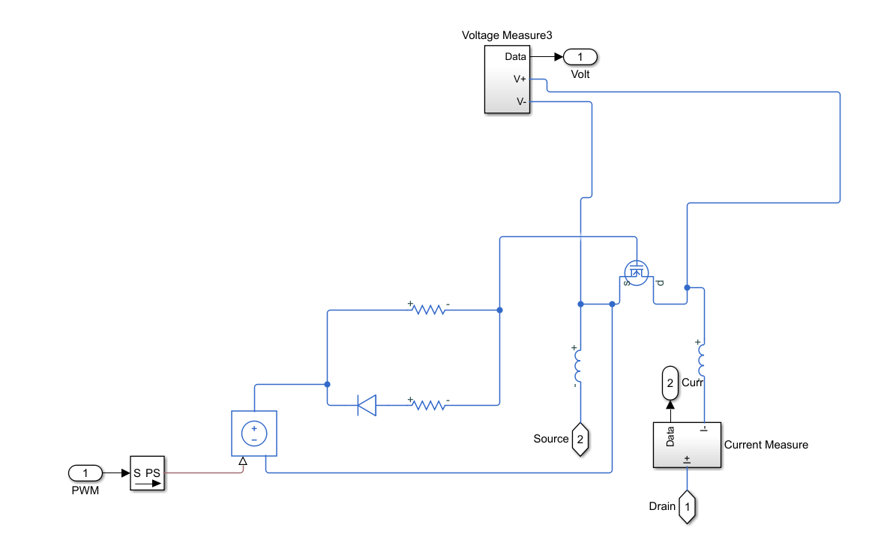

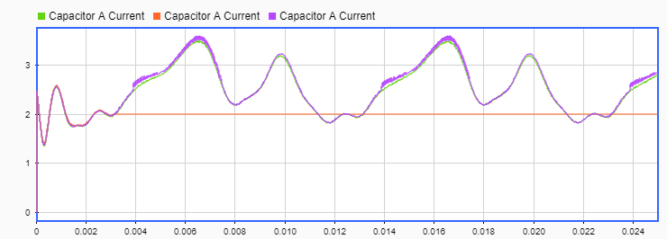

Figure 1: Capacitor Current RMS (Sample Time in order: 10ns, 1ns , 5ns) with Parasitics

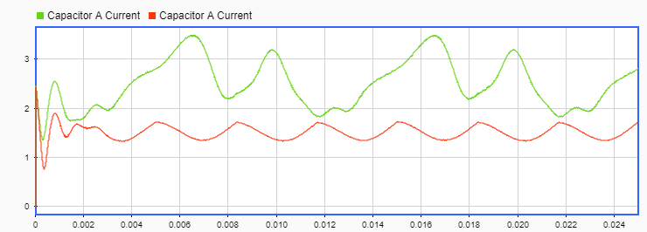

Figure 2:Capacitor Current RMS (Sample Time: 10ns) – with and without Parasitics

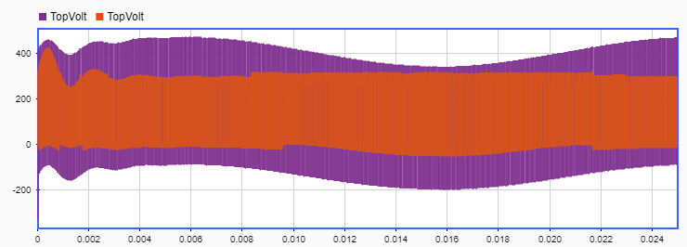

Figure 3: Leg A, Top Switch DS Pin Voltages (Sample Time: 10ns, 1ns) without Parasitics

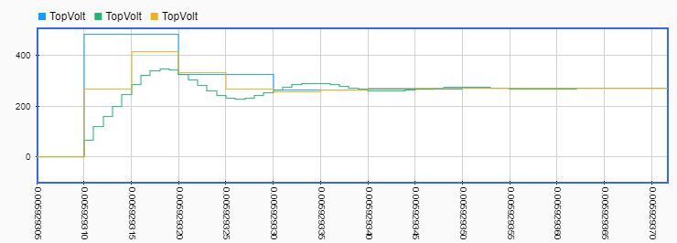

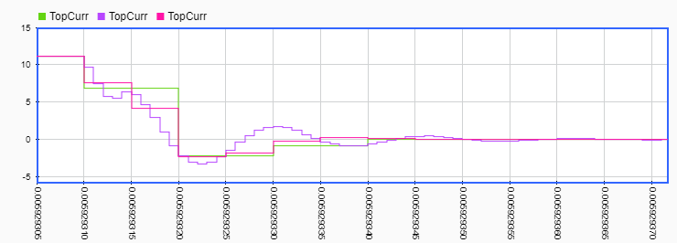

Figure 4: Leg A, Top Switch DS Pin Voltages and Currents (Sample Time: 10ns, 1ns, 5ns) with Parasitics for Turn-OFF

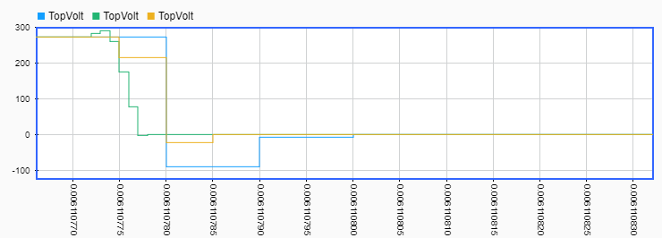

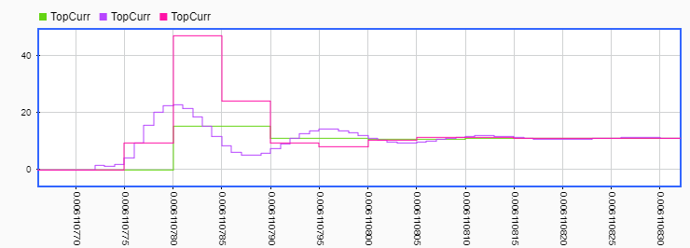

Figure 5: Leg A, Top Switch DS Pin Voltages and Currents (Sample Time: 10ns, 1ns, 5ns) with Parasitics for Turn-ON

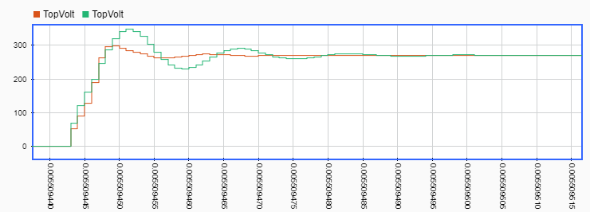

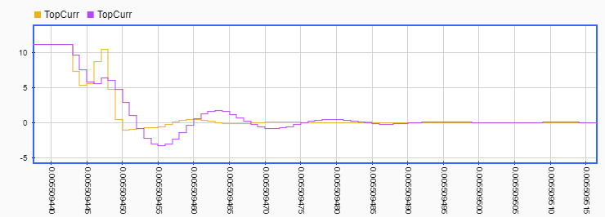

Figure 6: Leg A, Top Switch DS Pin Voltages and Currents (Sample Time: 1ns) without and with Parasitics for Turn-OFF

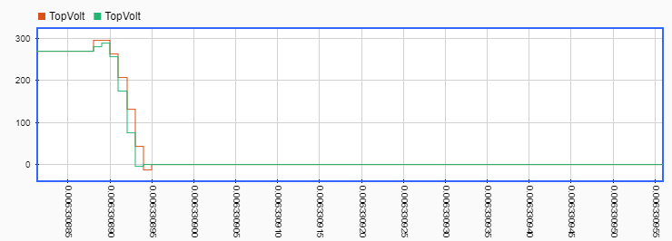

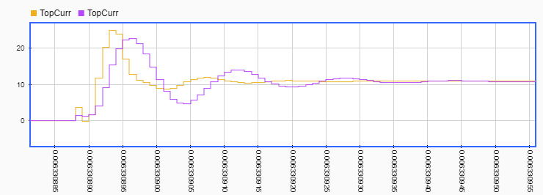

Figure 7: Leg A, Top Switch DS Pin Voltages and Currents (Sample Time: 1ns) without and with Parasitics for Turn-ON

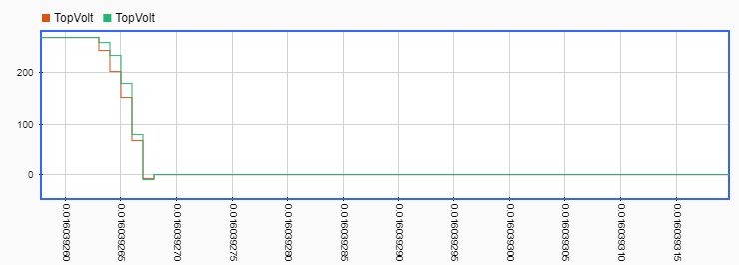

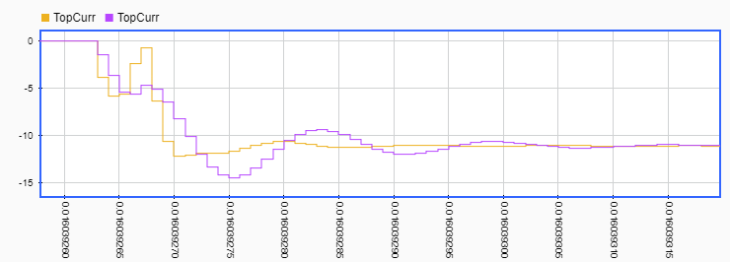

Figure 8: Leg A, Top Switch DS Pin Voltages and Currents (Sample Time: 1ns) without and with Parasitics for Turn-ON

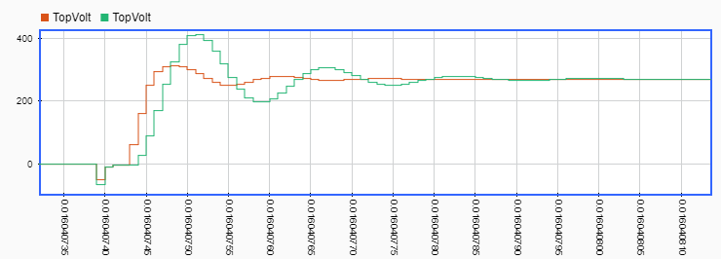

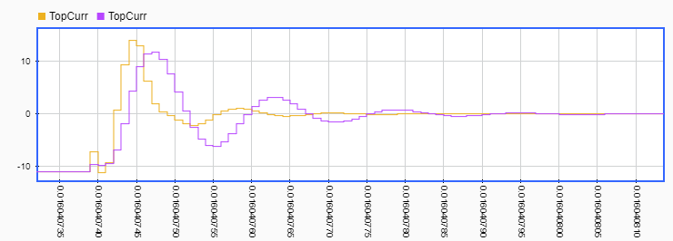

Figure 9: Leg A, Top Switch DS Pin Voltages and Currents (Sample Time: 1ns) without and with Parasitics for Turn-OFF

## BONUS

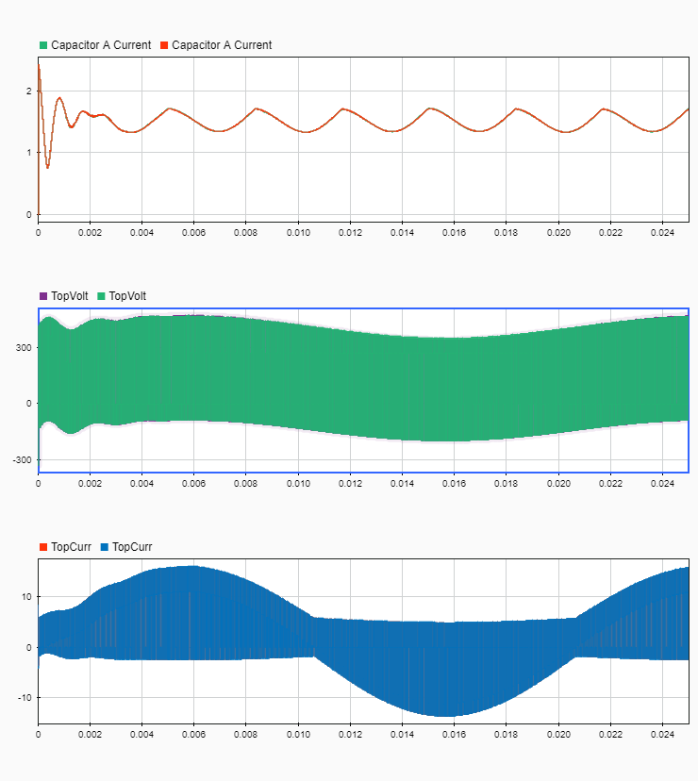

Figure 9: Comparison Figure (Sample Time: 10ns) without and with ESL for no parasitic case